

**PRACTICAL LAB - 2**

**DIGITAL LOGIC DESIGN**

**Assign by: SIR ABDUL RAFAY**

**Prepared by: Muhammad Aamir**

**1. Verify following Rules of Boolean Algebra by designing them using Circuit Makers.**

**Identity Law:**

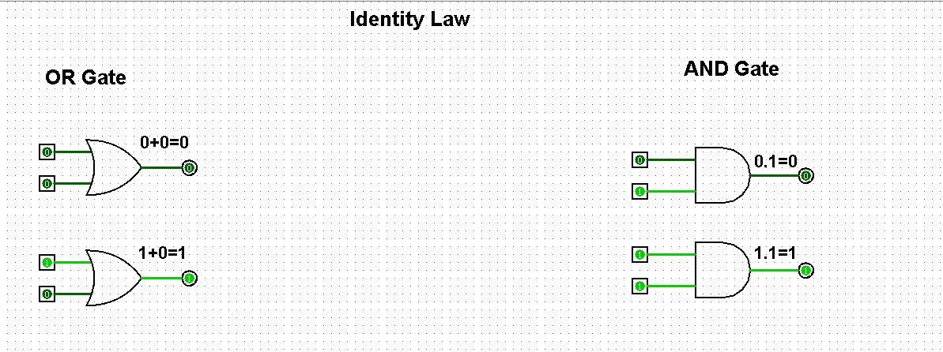

**Idempotent Law:**

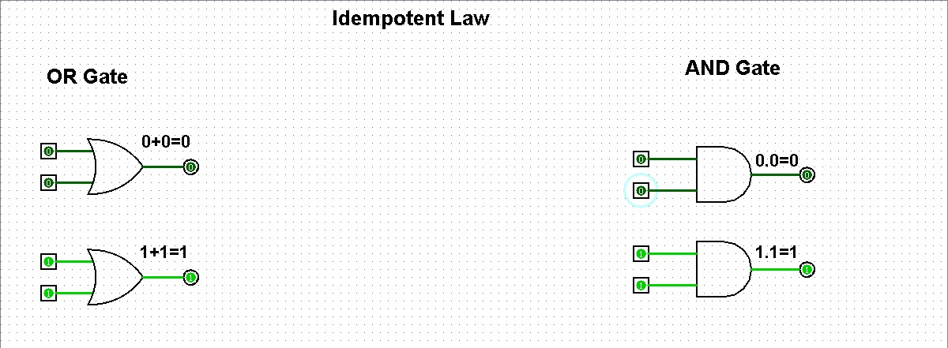

**Complement Law:**

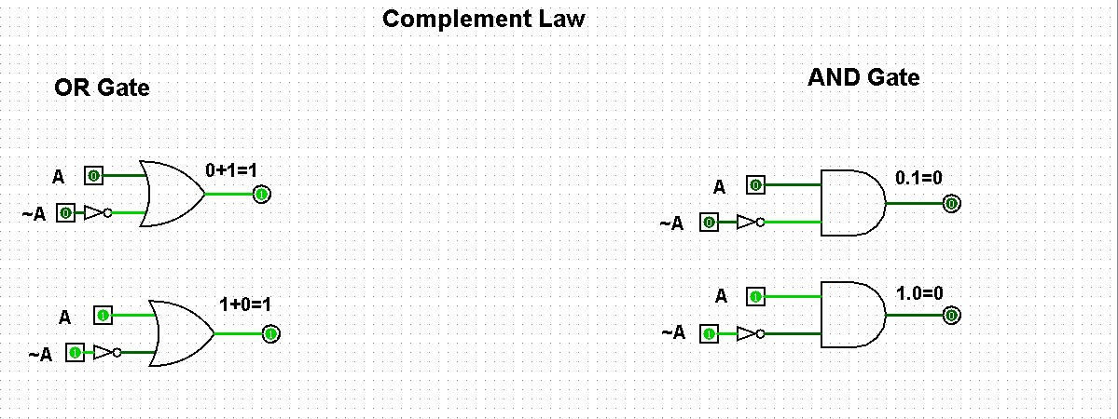

**Involution Law:**

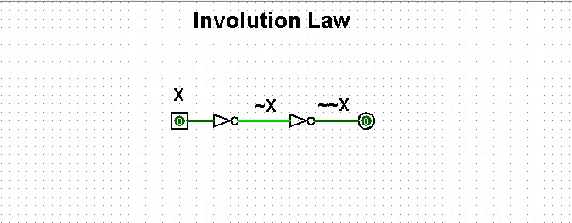

**Commutative Law:**

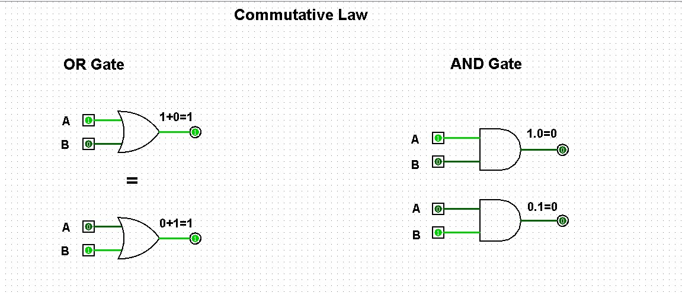

**Associative Law:**

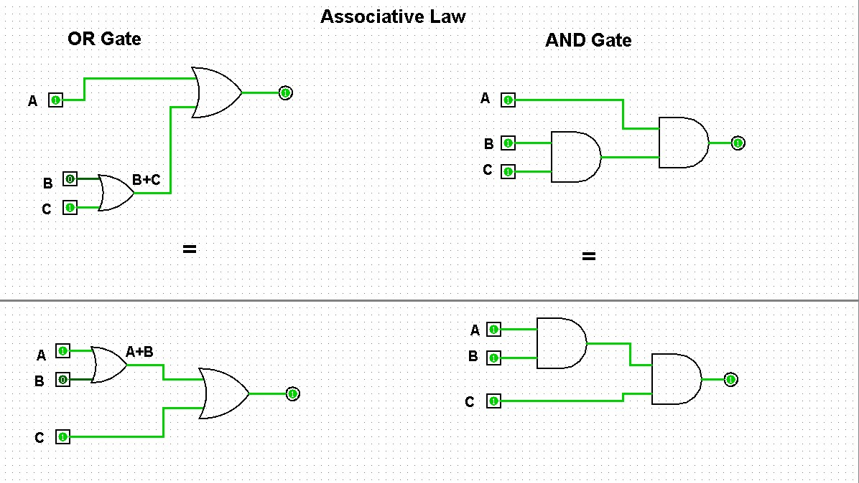

**Distributive Law:**

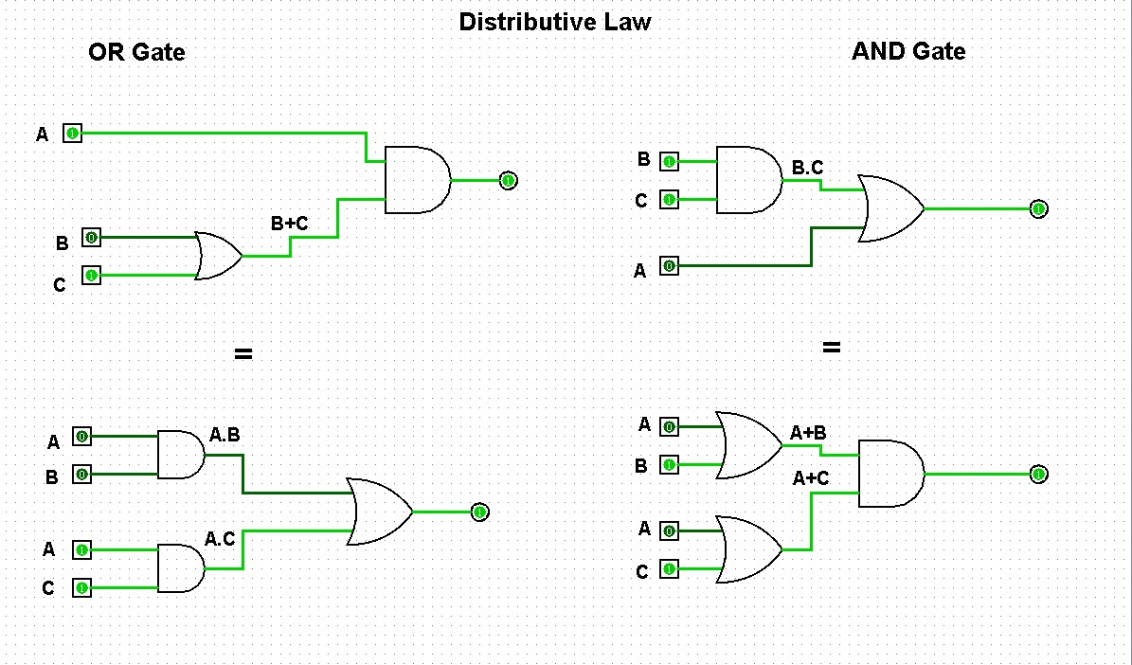

**2. Simplify the expressions 1. F=(A+(BC)’)’**

**Ans:**

F = [ A ] ’ [ ( B C ) ’ ] ’

F= A ’ B C

2. F=(AB+CD)’

**Ans:**

F = ( A B ) ’ ( C D ) ’

3. Use DE Morgan’s Theorem to prove that this NAND gate circuit performs the exact same function:

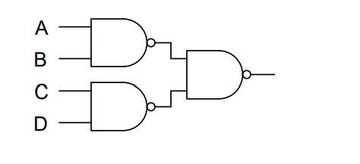

Sol:

# F = [(AB)’ (CD)’]’ //BREAKING LONGEST COMPLIMENT

F = [(AB’)’ + [(CD)’]’ //COMPLIMENT LAW

F = AB + CD

4. Apply the principles of DE Morgan’s theorems to the simplification of a gate circuit:

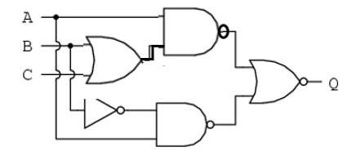

SOL:

# F = [{A (B+C)}’ + (AB’)’]’ //BREAKING LONGEST COMPLIMENT

F = [A (B+C)] . (AB’) // DISTRIBUTIVE LAW

F = (AB + AC) . AB’ // MULTIPLYING

F = (AB’) (AB) + (AB’) (AC) //A.A=A , B.B’=0

F= A(0) + AB’C

F= AB’C